WEATHER APP
AIM: Objective: In this project, you will create a web-based weather application that allows users to enter a location and retrieve the current weather conditions for that location. The app should display details such as temperature, weather description, and an icon representing the current weather.
IMPLEMENTATION:
- Created this weather app project using,
- Html for structuring the app.
- CSS for layput and styling
- Javascript for integrating and for ffetching weather data
- Integrating with a public weather API

- The app displays the details such as,
- Temperature
- Weather discription
- Icon representing the current weather
- Humidity
- Wind speed
- Additional 5day forecast displays all the details as the current day.
- Current location identifier

- Basic features included,
- User input: Has a text input field where users can enter the name of a city or a location of which they want to check the weather forecast.
- Submit button: on clicking the submit button, it triggers the weather data retrival.
- Display weather data: After a user submits a location, the weather app displayss the current weather conditions for that location. This includes temperature (in Celsius), weather description (e.g., "Sunny," "Cloudy," "Rainy"), and an icon representing the current weather condition.
- Styling: Applied CSS to make the weather app visually appealing. Ensuring it's responsive and user-friendly.
- Use of Public Weather API: used a public weather API to fetch weather data for the entered location. Used the popular OpenWeatherMap API (https://openweathermap.org/), which provides a free tier.
- Error Handling: Implemented error handling in case the user enters an invalid location or if there are issues with the API request. Provides appropriate error messages to the user.

SCREENSHOTS:
- HOME PAGE:

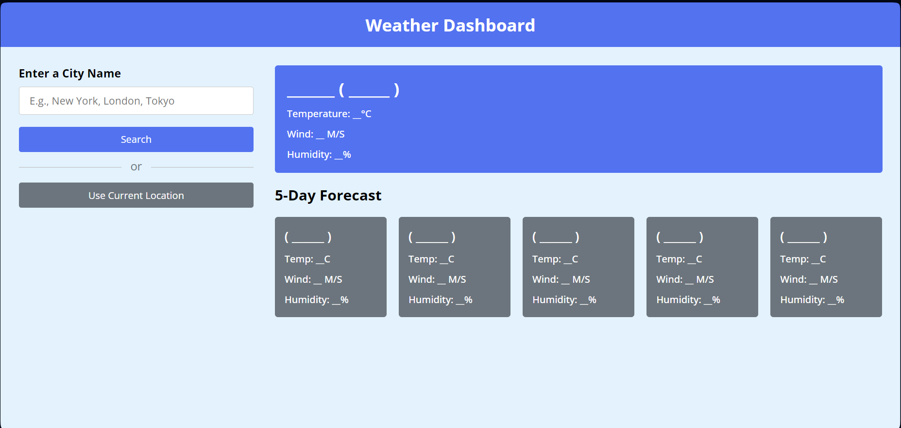

- ENTER A LOCATION NAME:

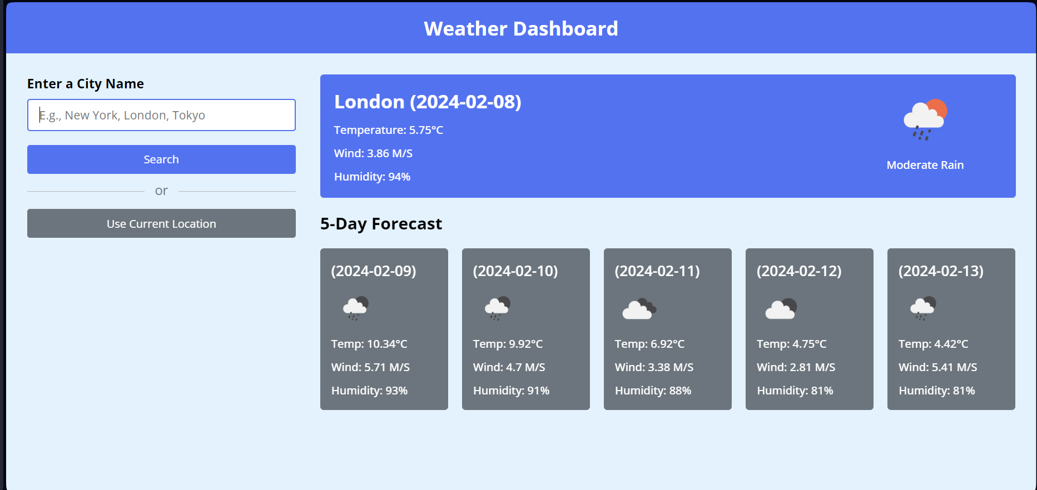

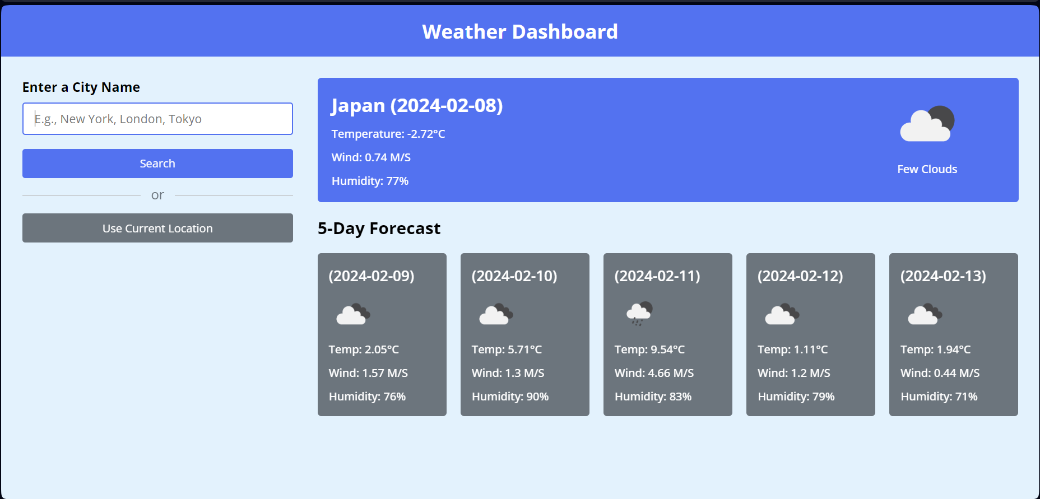

- CUREENT LOCATION IDENTIFIER:
- GRANTING PERMISSION:
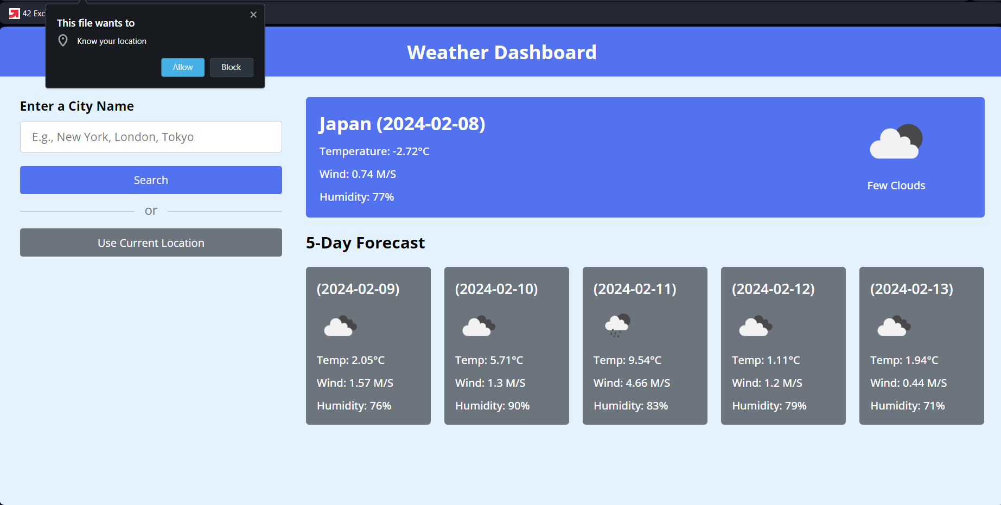

- DISPLAYS CURRENT LOCATION:
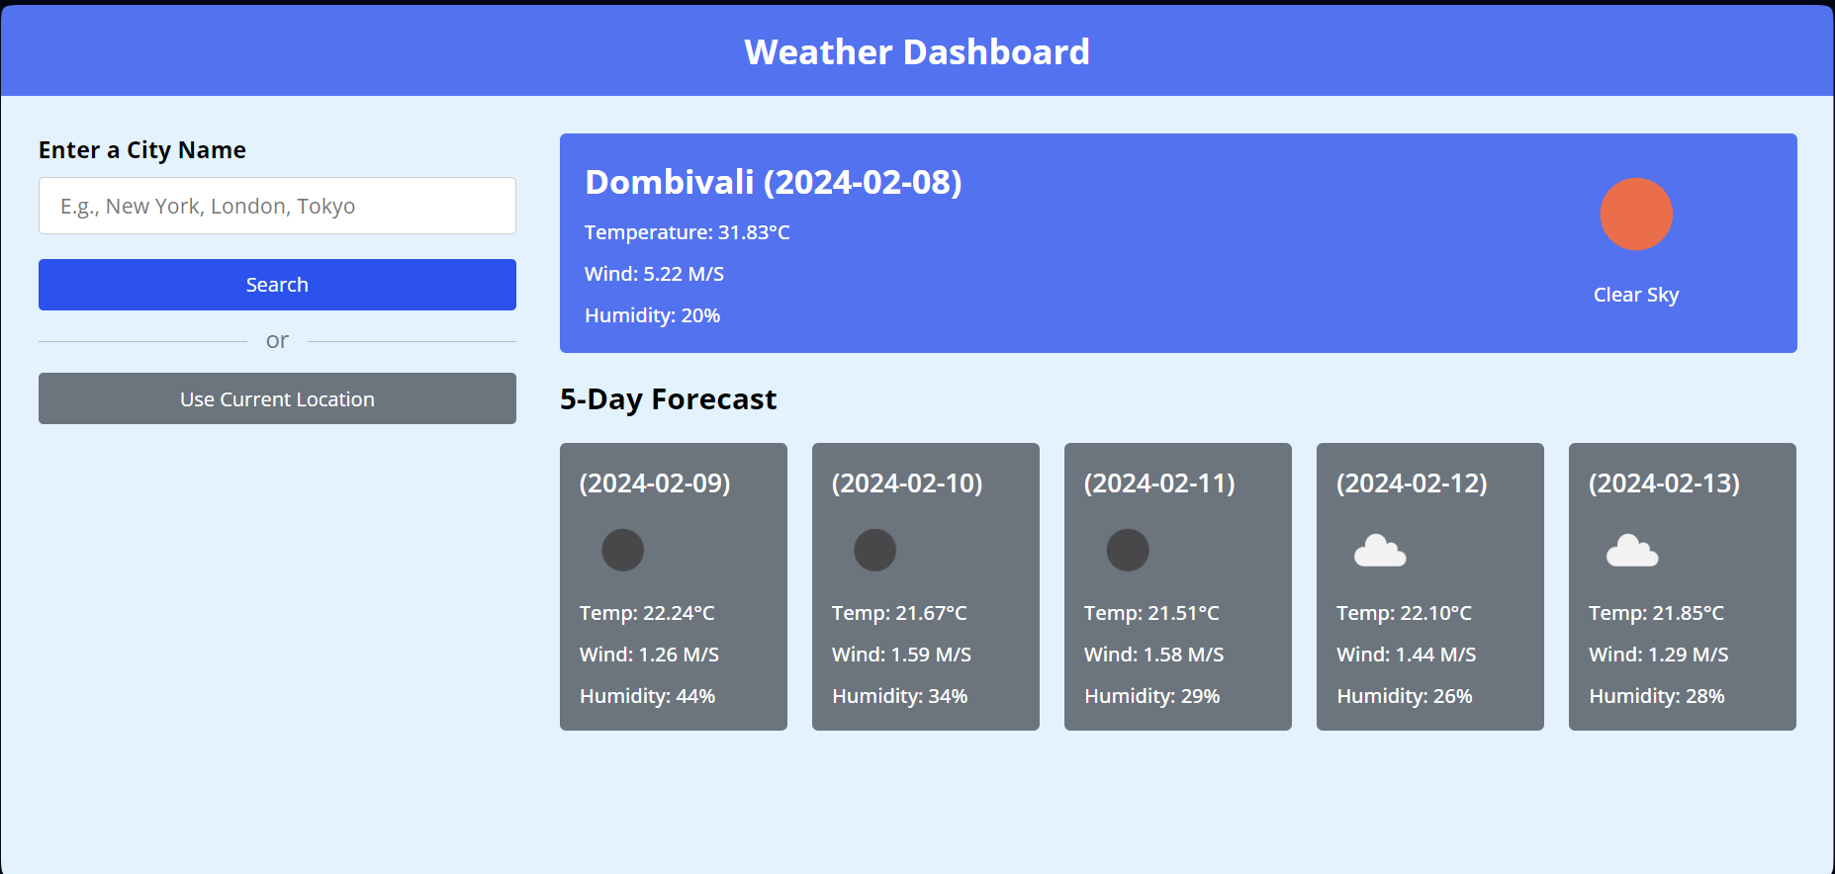

GUIDE TO OPEN THE PROJECT:
- Extract the weatherapp.zip file from the given drive link into your device.
- After extracting open the weather app folder in your device and run the index.html in your preferred browser or default browser.

